NEW CLASSROOM BLOCK AND SANITATION FACILITIES TRANSFORMS EDUCATION IN PAKWACH DISTRICT

Night Akello

Communication Officer-Pakwach District
Pakwach District Local Government has commissioned new education infrastructure at Payungu Primary School in Alwi Sub-county and Kuba Primary School in Pakwach Sub-county, significantly improving learning conditions for hundreds of pupils.
At Payungu Primary School, a three-classroom block worth UGX 128.78 million and a two-stance VIP latrine with a urinal worth UGX 14.94 million were commissioned under the School Facility Grant (SFG). The projects have addressed long-standing challenges of classroom congestion and inadequate sanitation.
Speaking during a phone interview, the Head Teacher, Mr. Eston Opakrwoth, said the new classroom block has greatly transformed the school. He noted that when he was transferred to the school, three classes—Primary One, Primary Three, and Primary Five—were studying under trees due to shortages of classrooms.
“With a total enrolment of 923 learners, the newly constructed classroom block has enabled all pupils to study in a conducive environment,” he said, adding that the new latrine has also improved sanitation at the school.
Mr. Quatina Abeka, a parent at the school, expressed gratitude to the Government of Uganda for the intervention, noting that it has eliminated the challenge of pupils learning under trees and created a better learning environment.
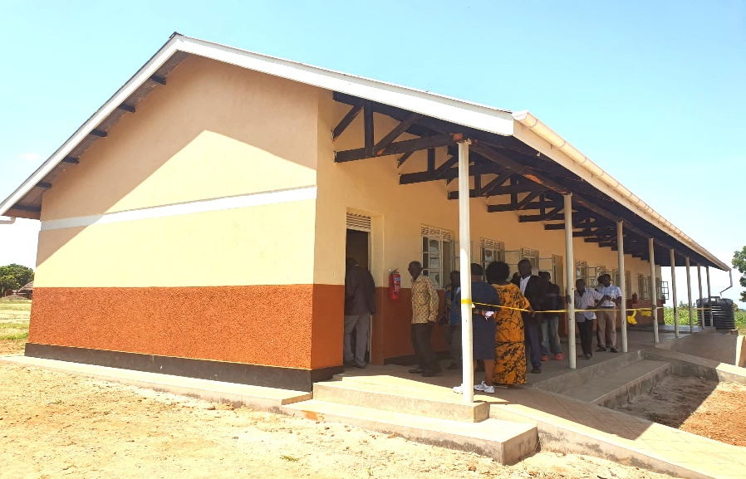
The newly commissioned 3 classroom block at Payungu P/S in Alwi Sub County
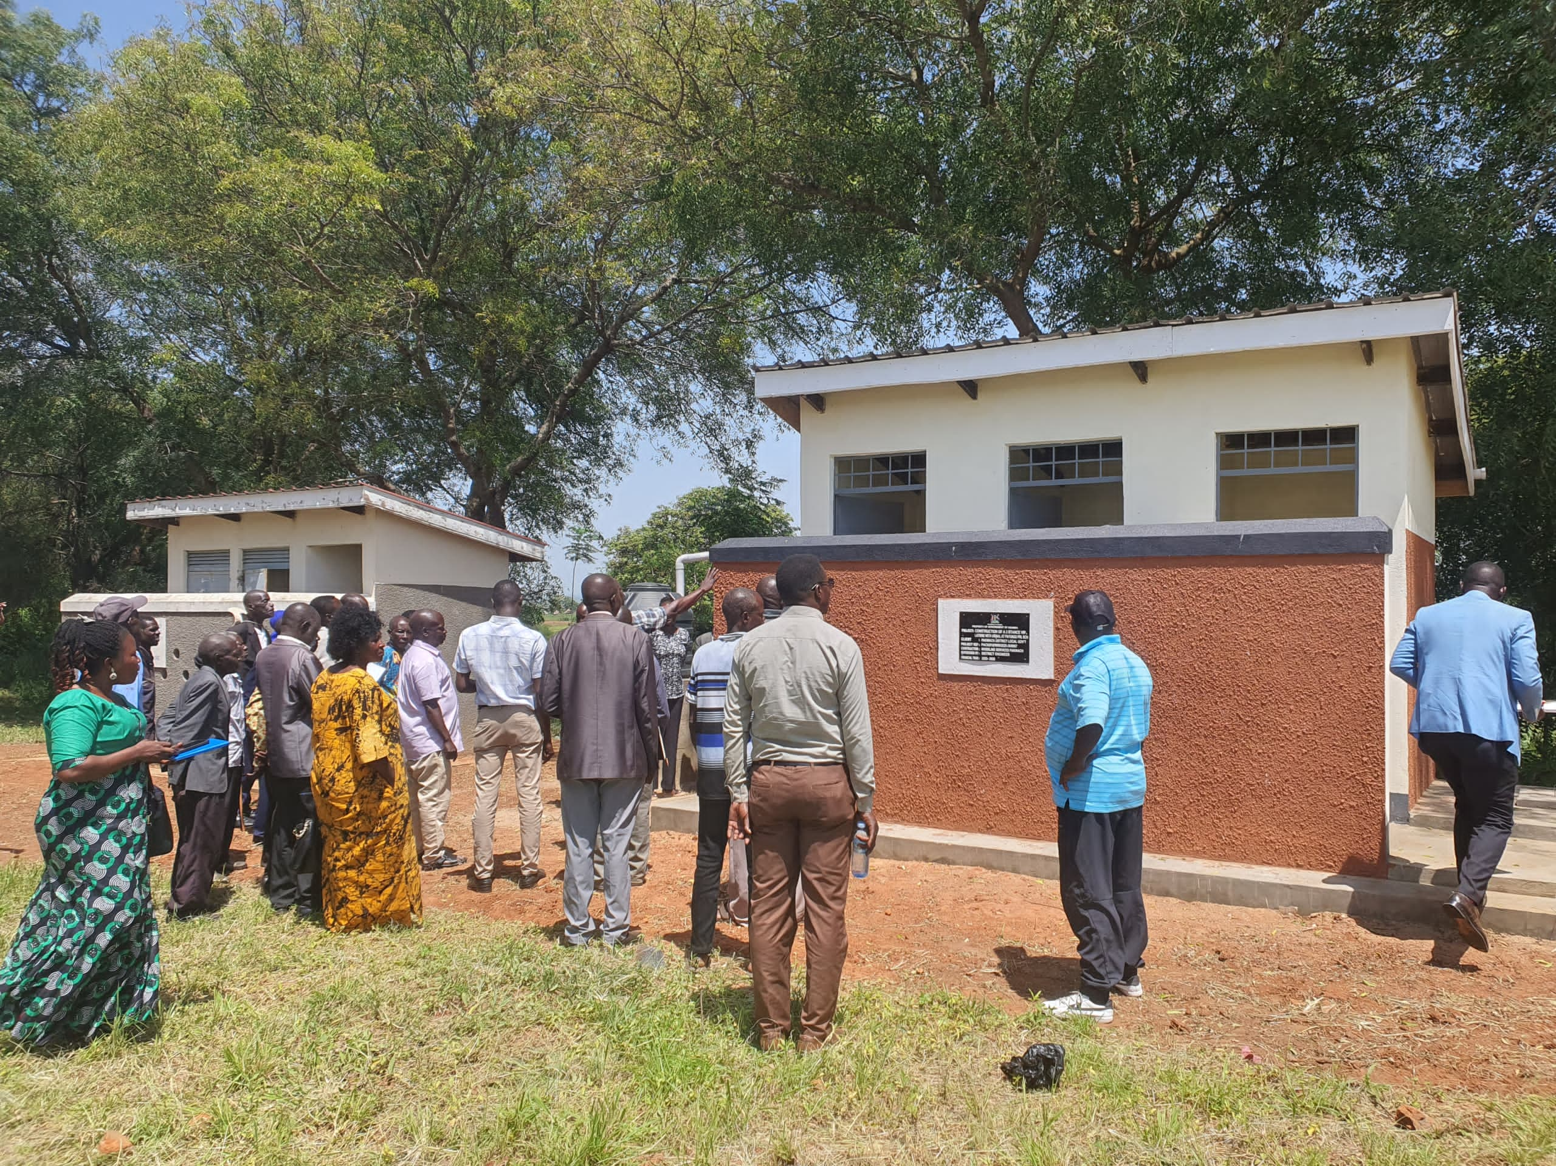
The 2 stance VIP Latrine with Urinal at Payungu P/S in Alwi sub county
Meanwhile, at Kuba Primary School in Pakwach Sub-county, a three-classroom block worth UGX 124.16 million was also commissioned under the School Facility Grant. The school, which currently has an enrolment of 383 learners and operates from Primary One to Primary Six, had previously struggled with inadequate classroom space, forcing learners in Primary Two, Primary Three, and Primary Five to study under trees.
The new facility has effectively addressed the classroom shortage, providing a more conducive environment for teaching and learning.
The projects were officially commissioned by Assistant Resident District Commissioner, Fiona Atimango, who urged community members to take ownership of the facilities and ensure they are properly utilized for the benefit of learners and the future generation.
The newly commissioned projects underscore the Government of Uganda’s commitment to strengthening education infrastructure and improving access to quality education across the Country.

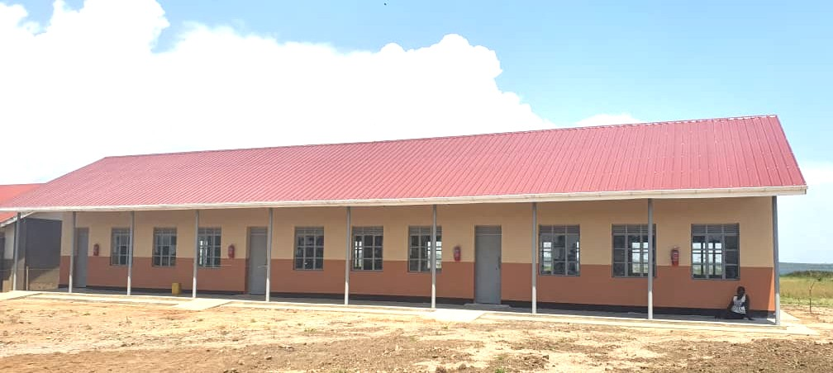
The commissioned 3 classroom block at Kuba P/S in Pakwach Sub County

